Hartland Community Recreation!

In Hartland we have many active children and even adults so we have to find a way to give them opportunities to be active.
- We have soccer programs all the way from U-8 up to U-18
We even have our own competitive teams.
- 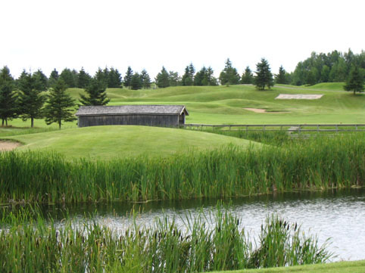We Have a beautiful 18-hole golf course and the prices are wicked cheap.
- We have many school sports teams.
- We try to have as many community sports events as we can every year.
- We have summer ball hockey programs.
- In the winter we even have a community outdoor hockey rink.
- We Also have 7 different sports camps.
Where is Hartland

Geography
- Hartland is situated on the Saint John River in the central-western portion of the province in the agricultural heartland of Carleton County.
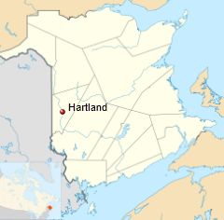
History in Hartland

- The first settler in the area of what would become Hartland was William Orser (b.1762) and his son William Jr.[1] William traveled there from New York with his wife and six children. His wife died of an illness and he remarried to a widow, Mary Blake, who also had six children.

